**Exercises for running U-SQL using visual studio in local environment**

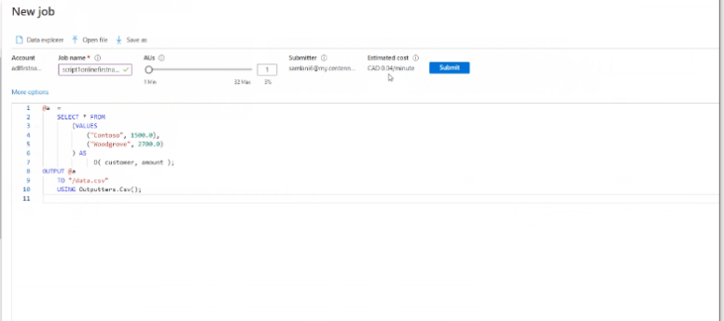

screen shot for exercise 1, 2 and 3

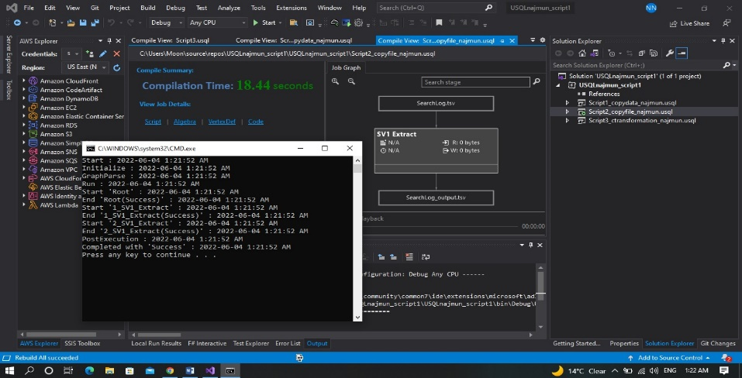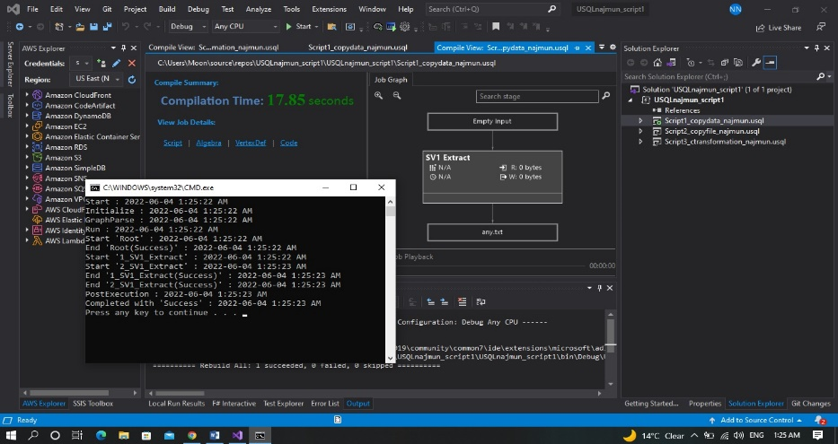

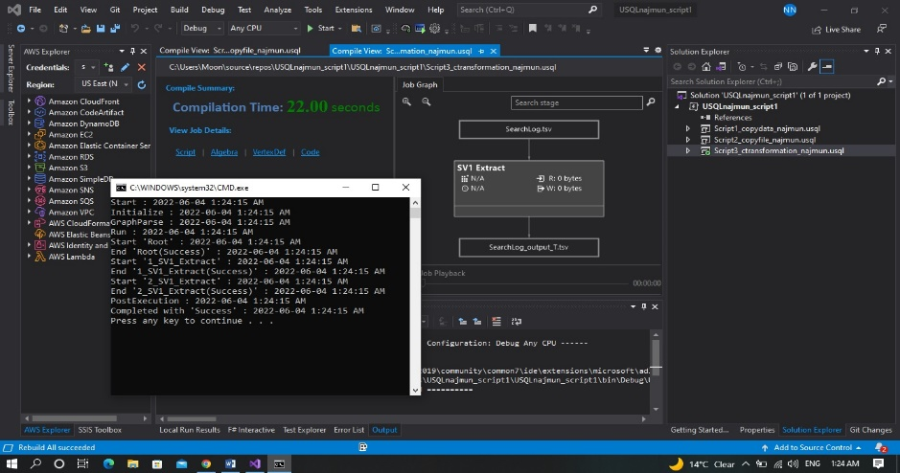

# **Exercises Azure Data Lake Analytics**

Exercise #1 : Create Datalake account and submit a U-SQL script using the Azure portal

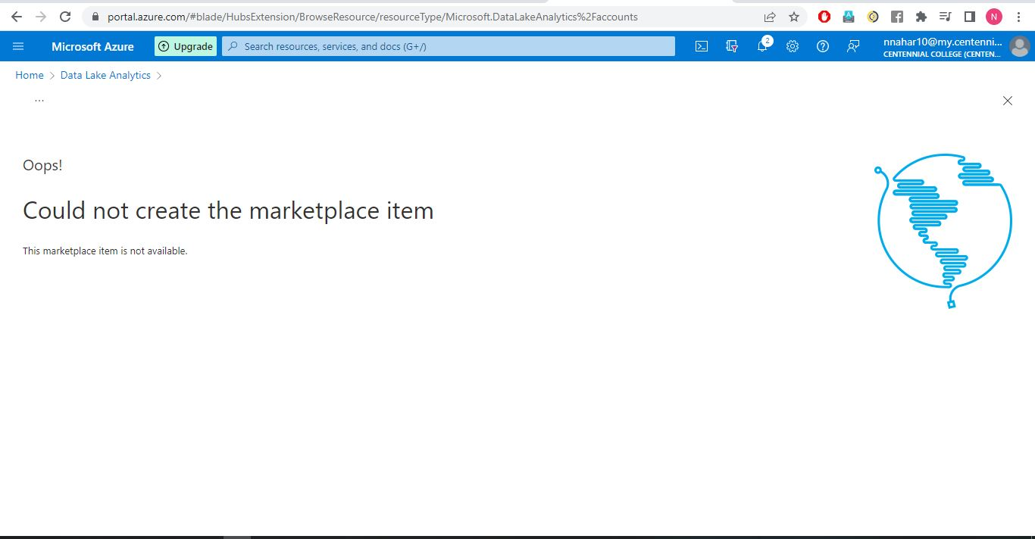

**Exercise #2: Use Powershell to access the datalake and run a U-SQL script**

